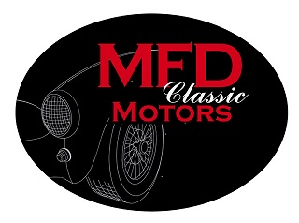

MFD Classic Motors Driving Experience Sponsorship Levels

MFD Classic Motors presents our 2020 Driving Experience,
Celebrating our 29th year on the track
Grattan Raceway in Belding, Michigan

Partnership opportunities for our April 24th-26th, 2020 event:

Gold- $2,500 Paddock Area Sponsorship

Banner and signage in the Paddock. Space in the paddock reserved for your display kiosk, product placement or information booth. Space for up to three promotional vehicles, two 2 day driver entries with instruction provided. Your logo included in all of the MFD social media and email correspondence to the participants. Announcements during all drivers meetings. Product and company information included in the drivers registration packages.

Silver- $1,750 Banquet Host Sponsorship

Sponsorship of the Saturday evening banquet at Flo’s. Banner and signage at banquet, announcements during all drivers meetings. Credit in all social media contacts with event participants, one two day driver entry with instruction provided.

Bronze- $1000 Classroom and In Car Exercises

Banner in classroom area, product/company information in drivers registration packages and social media. Announcements, logo on MFD email correspondence with event participants.

1701 Park Drive Traverse City, MI 49686 231.947.3850 mike@mfdclassicmotors.com

